Special Educational Needs (SEN) School Information Report

Welcome to Guardian Angels Primary School’s Special Educations Needs information report.
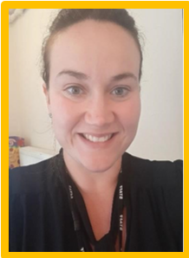
My name is Laura Potter. I am the SENCO of Guardian Angels Primary School. My role is to work with children, parents, teaching staff, school leaders and outside agencies to do everything we can to support children with Special Educational Needs and Disabilities.
The information report tells you about how the staff at Guardian Angels Primary School support children with Special educational needs and disabilities (SEND).
Contact details:
Phone: 0121 7472782
Email: l.potter@grdangel.bham.sch.uk

At Guardian Angels Primary School we strive to support all our children and enable them to enjoy and achieve at our school. Quality teaching is vital, however for some children there are occasions when further additional support may be needed to help them achieve their targets.
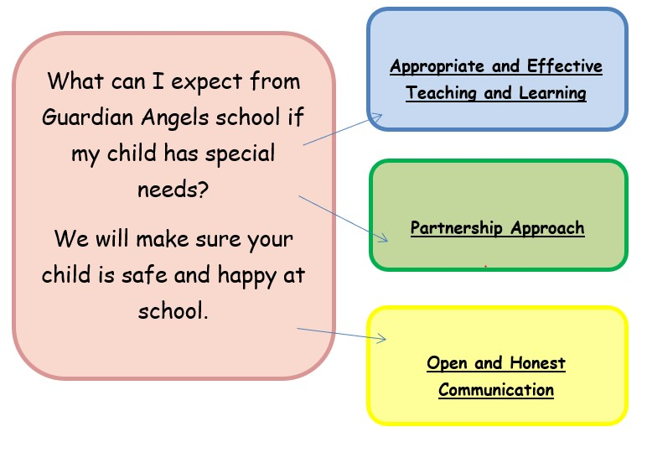

If you are concerned about Your child’s needs, you should speak to your child’s teacher first. Our SENCO will meet with you if the class teacher is unable to help with your query.
Mrs Potter is the SENCO. Mrs Potter has day to day responsibility for helping our pupils who need additional support, those with SEND and children who have an EHCP. You can make an appointment to see Mrs Potter by speaking with school office or email to enquiry@grdangel.bham.sch.uk.

What is the SEND information report?

- The SEND Information Report aims to outline how the SEND Policy will be implemented within Guardian Angels Catholic Primary School.
The SEND Information Report will detail the offer for SEND within Guardian Angels Catholic Primary and ways in which parents, children and young people may access the support required.

Which legislation and guidance informs this report?

This SEND information report is based on the statutory Special Educational Needs and Disability (SEND) Code of Practice and the following legislation:
- Part 3 of the Children and Families Act 2014, which sets out schools’ responsibilities for pupils with SEN and disabilities
- The Special Educational Needs and Disability Regulations 2014, which set out schools’ responsibilities for education, health and care (EHC) plans, SEN coordinators (SENCOs) and the SEN information report

What do we mean by SEND?

SEND refers to a learning difficulty or disability which calls for special educational provision to be made, for example, where a child has:
- a significantly greater difficulty in learning than the majority of others of the same age, or
- a disability which prevents or hinders them from making use of facilities of a kind generally provided for others of the same age in mainstream schools
Special educational provision is additional to, or different from, any provision made generally for other children or young people of the same age by mainstream schools.

What SEND needs do we provide for at
Guardian Angels Catholic Primary?

Guardian Angels Catholic Primary values the contribution that every child can make. We are committed to offering an inclusive curriculum to ensure the best possible progress for all of our pupils whatever their needs and abilities. All children with SEND are valued, respected and equal members of the school. Every effort is made to ensure that pupils identified as having SEND are fully integrated into mainstream classes. and have full access to the National Curriculum and after school activities.
As such, provision for pupils with SEND is a matter for the school as a whole.
“All teachers and key workers are teachers of pupils with SEN”.

Help and support can be provided for the following areas of need:

Area of need | What this could look like
  Cognition and Learning | This area includes general learning difficulties (which may be moderate or severe), profound and multiple learning difficulties (PMLD) and specific learning difficulties (SpLD).  SpLDs include: dyslexia (difficulties with reading and spelling), dyscalculia (difficulties with number and calculation), and dyspraxia (or ‘developmental coordination disorder’, difficulties with motor planning).
  Communication and Interaction | This area includes speech, language and communication needs  (SLCN), which could mean difficulties with speech production, the understanding of language, the expression of language or a combination of all three. It also includes difficulties with the social use of language.
  Social, emotional and mental health difficulties | This area includes children who find it difficult to manage their feelings and behaviour. Challenging behaviours are displayed for many reasons, which may be indicative of underlying mental health difficulties (such as anxiety or  depression), or emotional issues (such as disordered attachment). Some children have disorders such as ADHD (Attention Deficit Hyperactivity Disorder) or ADD (Attention Deficit Disorder) which affect how they behave.
  Sensory and Physical needs | This area includes sensory impairments, such as visual impairment (VI) and hearing impairment (HI), as well as physical disabilities such as cerebral palsy. Children with these disabilities will usually access support from the specific local team, which may be a combination of education and health services.

The SENDCO will monitor the support your child is receiving to make sure it is appropriate and effective. They will also aim to provide any additional resources your child may need.

Appropriate and Effective Teaching


All staff have been trained in the Education Endowment Foundation (EEF) “5 a day principles” to promote high-quality teaching within the classroom. 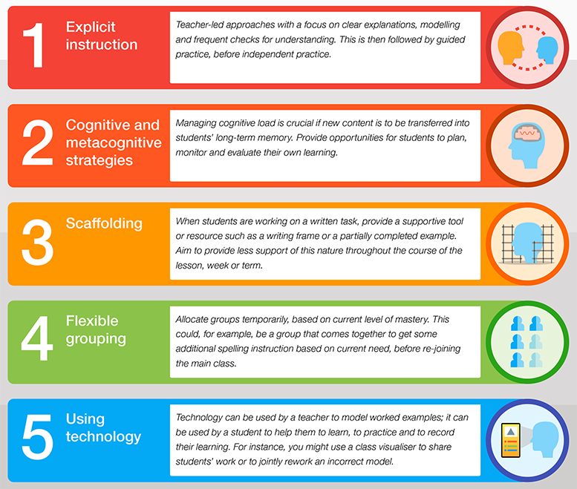

All school staff receive appropriate training so they have the knowledge and confidence to support children’s needs.
- Staff attend workshops on specific needs, including those organised by outside agencies.
- Teaching staff will be able to accurately assess the level children are working at and aim to differentiate the curriculum to meet the needs of your child.

- Your child will receive Quality First Teaching in class, where the class teacher will aim to provide the support your child needs through adapting the curriculum and providing carefully chosen resources. Further support may then be given through interventions to help support your child in a specific area and advice may be sought from Outside Agency Support Services, if appropriate.
- A record of all the support you child has received is kept by school to ensure that the support is the most effective for your child. This information is recorded on a provision map. Provision is reviewed and monitored regularly.
- Support for your child will be provided through matching the work within the classroom to their needs (Quality First Teaching), through small group work or one-to-one work, and through intervention programmes to target specific areas of learning, as appropriate.
- Adaptations can be made as appropriate to accommodate children with physical difficulties, hearing difficulties, or sight difficulties.
Details of this can be found in the school’s Accessibility Action Plan as part of our commitment to the Equality Act 2010.
- All pupils, including those with SEND are set targets as to the amount of progress they are expected to make. This is monitored regularly to ensure progress is good.
- Staffing arrangements are carefully considered to match the needs of individuals and staff specialisms/previous training are taken into account when identifying who will provide extra support for your child.
- Children will be assessed against the National Curriculum criteria or Pre Key stage levels, as appropriate. Staff will receive training in this and school will continue to be moderated to ensure accurate assessment.
- Please also refer to the school’s curriculum and assessment policies.

This support follows a graduated approach (also known as ‘Assess, Plan,
Do, and Review’) as outlined in the revised SEN Code of Practice 2015
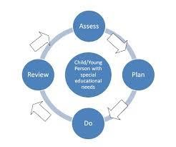
Within this graduated approach we follow a tiered system of support for pupils with additional needs.
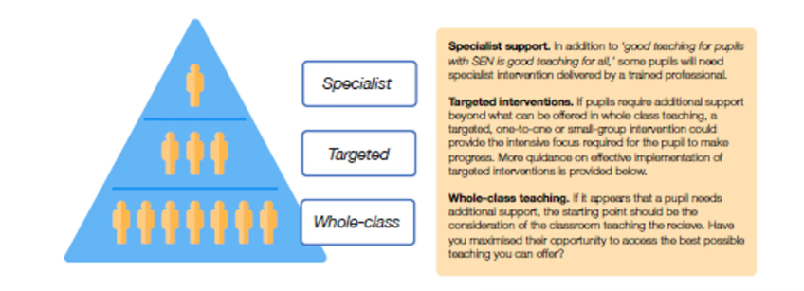

First stage- Universal support
Concern and identification of need, School staff or parents can initiate this stage. It is an informal stage where class teachers in conjunction with the parents/carers will discuss the concern about the child and share experiences.

A first stage concern sheet is completed, and it is agreed what differentiation/adaptations the child will be offered as part the High Quality teaching they receive in class. High Quality teaching is that which is differentiated and personalised to meet the individual needs of the pupils in each class/set. A note of this meeting will be taken, and a date agreed with parents to review the impact of these approaches. At the review, if the child has made the expected progress it may be agreed that the extra differentiation has had a good impact on the child’s progress and that those strategies will remain in place. If, however, there has been little or no improvement in the pupil’s progress then there will need to be further reflection on the strategies and approaches that are currently being used and the way these might be developed.

The SENCO may be consulted for support and advice on further adjustments. Again, a note of this meeting and the approaches agreed will be taken and a date agreed with parents to review the impact of these further adjustments. Following a period of additional provision (at least half a term) the additional support will be reviewed. The impact and quality of the support and interventions should be evaluated, along with the views of the pupil and their parents. This will feed back into the analysis of the pupil’s needs. If the review leads to the conclusion that the child needs help over and above that which is normally available within the class or school we will move the child through to the next stage.

Second stage- Targeted support
A pupil passport which outlines the child’s individual difficulties alongside suggested strategies will be developed and distributed to all staff who work with him/her and a copy given to parents. Pupils are encouraged to contribute to these passports and be encouraged to discuss how they would like to be supported. At this point the child’s name will be added to the school’s SEN list and he/she is considered to be receiving SEN SUPPORT. It may be decided that the pupil would benefit from some targeted work in a small group (Intervention group) usually run by a TA or on a 1-1 basis. Class teachers will then set up

small groups in conjunction with the Teaching Assistants where suitable interventions can be delivered. The effectiveness of these intervention groups are monitored carefully. Class teachers will discuss individual children’s progress with their parents at end of term review meetings and informally upon request.

Specialist Support
For those children with more complex special educational needs, there may be the need for individual targets and specialised support. Outside agencies may be consulted (with parental permission) to support school in ensuring the best outcomes for pupils. Where this is the case, parents are invited to regularly review targets termly with the class teacher and or the SENCo, and set new ones as appropriate.
In some cases, after reviewing the targets and outcomes, it may be necessary to move a pupil further on within the ‘SEN Support’ category to a Send Support Provision Plan (SSPP) or and Educational Health Care Plan (EHCP) This is reviewed annually, and progress carefully monitored.

More information about EHCP’s can be found on the Birmingham local offer link: https://www.localofferbirmingham.co.uk/education-health-and-care-plan/

Partnership Approach


The school will involve you and your child in all decisions and listen to your views surrounding your child’s area of difficulty or the support which they are receiving.
In our school, if we feel a pupils needs more specialist help we can work with the following people.
Agency or service | Who they work with
Educational Psychologist  (EP)  Taniqua Fuller | Children with complex needs and where an application for an EHCP assessment is required.
Communication and Autism  Team (CAT)  Cari-Ann Burden | Children who are being assessed for or already have a diagnosis of Autism.
Pupil School and Support  Service (PSS)  Kerry Riches-Orme | Children who are working below expected level or who have cognition and learning difficulties.
Speech and Language  Therapist (SLT)  Emma Daly  Sophia Evans (NHS link therapist) | Children who have difficulty with speech, language or communication.
Hearing Impairment team  (HI)  Stephanie Dawson | Supporting children with hearing difficulties.
Sensory and Physical Difficulties Support team (PDSS) | Children with physical disabilities that impact on their school access.
Occupational Therapist  (OT) | Children who need assistance and additional programs to support educational process.
School Nurse | Children with medical needs and their families.

We will work in partnership with you to identify the needs of your child and ensure that the correct support is in place, including family support if required.
You will be invited to attend review meetings, or asked to meet with a member of the Outside Agency Support team who is working with your child, to review their progress and the support that is in place. Your child will also be asked to contribute to the review of their targets and to their pupil passports as appropriate.
We may also carry out observations of your child working within the classroom to further our understanding of their difficulty.
This will involve looking at your child’s work and talking to your child about what they are doing and how they feel when working in class.
These observations and discussions ensure that we know your child well, including their interests and strengths, as well as the support they require.

When pupils leave or start Guardian Angels Primary we follow a transition plan.
This consists of SENCO organising transition meetings with parents, previous/ next educational setting to ensure pupils needs are communicated, that support is in place and pupils and family feel informed and secure throughout the process.

Pastoral Manager
Our Pastoral Manager is Mrs Hazel Tennant. She provides support and information to families. An appointment can be made with her through the school office or email at enquiry@grdangel.bham.sch.uk

SEND Governor
Mrs Potter regularly informs the governing body about SEND progress, training and work with our partners. The SEND Governor is Matt Sparling.

School adheres to the Children and Families Act 2014 which includes changes to the support for children with Special Educational Needs & Disabilities (SEND). This document named “0-25 Special Educational Needs and Disabilities Code of Practice” sets out how schools support children with SEND. Local authorities must publish a Local Offer, setting out in one place information about provision that is available and provision that is expected to be across education, health and social care for children and young people in their area who have special educational needs and disabilities (SEND). You can find more information about Birmingham’s local offer by visiting the following website:
https://www.localofferbirmingham.co.uk

Open and honest Communication


We will make all the information you need clear and easy to understand – please ask for a copy of the school’s SEND policy or find it on our website.
We will regularly meet with you, and your child, to discuss your child’s progress, and the outcomes of any support that is given, at parent’s evenings, at review meetings or after school.
The SENDCO will make sure that all necessary school staff are aware of your child’s needs. The SENDCO will monitor the support your child is receiving to make sure it is appropriate and effective. They will also aim to provide any additional resources your child may need.
If you think your child may need extra support, talk to your child’s class teacher, who will then discuss this with the SENDCO. School will meet with you to share any support that is being given or to plan new levels of support for your child. Support is put in place and regularly reviewed within school.
If further concerns arise we will contact outside agencies with your permission.
If your child requires extra support they will be given an Individual Provision Plan (IPP), which outlines the support they will receive and who is responsible for providing that support.

If your child has a behavioural issue as part of the area of need, they will also have a Positive Handling Plan and Risk Assessment, highlighting possible triggers and strategies to support the child. These are all reviewed regularly and reviewed or updated, when required.

Sometimes the language of SEND is difficult to understand as everyone uses lots of abbreviations. The table below outlines the abbreviation and its meaning, we hope this helps.
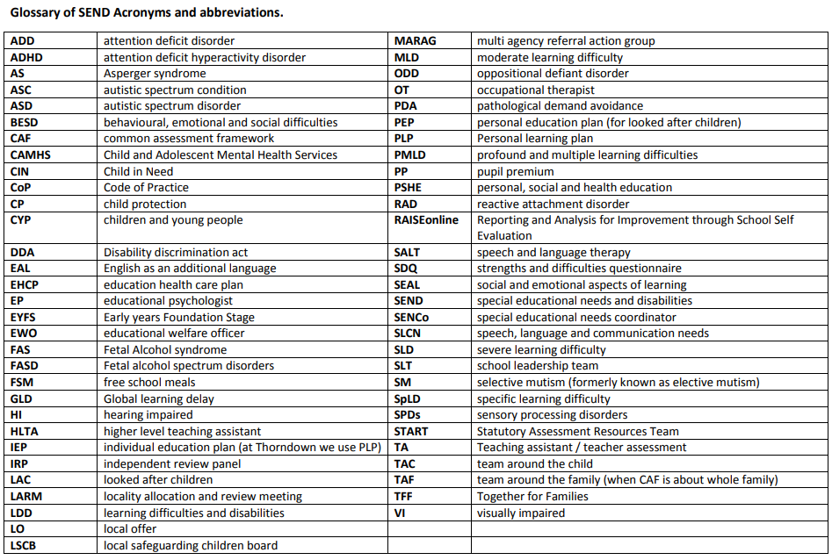

Reviewed on 22.09.25 Next review date: September 2026

Guardian Angels Resource Base
Autism Provision

As well as supporting children with special needs in mainstream we have our own specialist Resource Base provisions. All children who attend our provisions need to have a diagnosis of Autism and Education Health Care Plan. The Resource Base accommodates 8 pupils and has an appropriate number of teaching staff to accommodate the pupils needs.
At Guardian Angels Primary School, we recognise that some children who have a diagnosis of ASC can find the world confusing which in turn, can make school a challenge. Each child is an individual and it is our aim to equip them with specific strategies and support to promote their inclusion and reduce potential anxieties, so they can have a fun and enjoyable time at school.
We follow the SENDIT curriculum, which is tailored to meet children’s individual needs. We use teaching approaches that are tailored to the individual pupils such as structured teaching, social stories and visual support. The curriculum is also weighted to address the social, communication and sensory needs of the pupils. Our classroom provides an ASC friendly environment to ensure all pupils reach their full potential. All pupils work towards social integration and occasionally may integrate for lessons into mainstream education when it is appropriate for them.

Admission of children into the Resource Base will be decided by The Special Education Needs Assessment Review (SENAR) taking account of individual children’s needs, parental preference and consultation with the school. In addition, consideration will take on board the needs of the children within the Resource Base.

Admissions to our Resource Base are entirely separate from places in our main school and can only be allocated through SENAR /Birmingham Local Authority.

Sensory based classroom

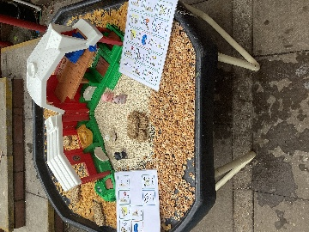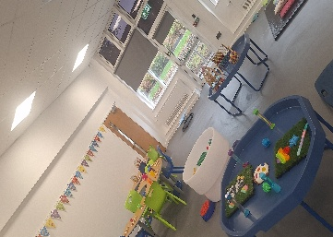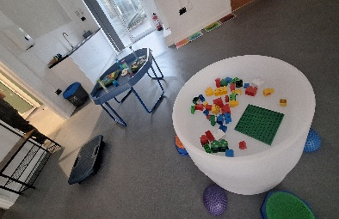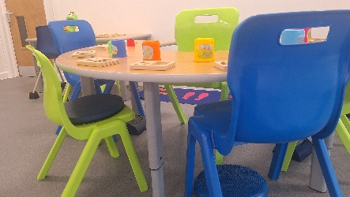

Semi-Formal based classroom
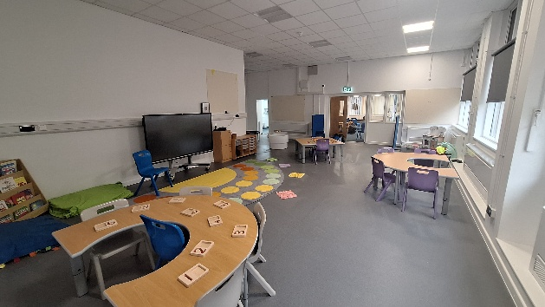

SIR reviewed: October 2026
SIR next review: October 2027

